**Clean Code Development (5 points)**

1. **Standard Naming Convention**

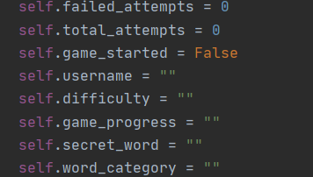

Used meaningful names for variables in the functions and classes and seperate words by underscores to improve readability.

1. **Functions**

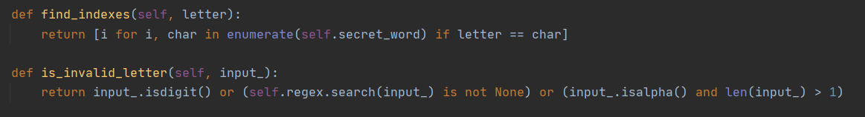

Defined functions that is relatively small and do only one thing in a better way. Used descriptive names for the functions and passed few arguments.

1. **Comments**

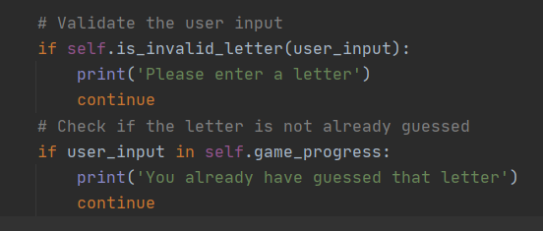

Used Comments to explain the functionality of code where necessary. Avoid misleading and noise comments.

1. **WhiteSpacing and Indentation**

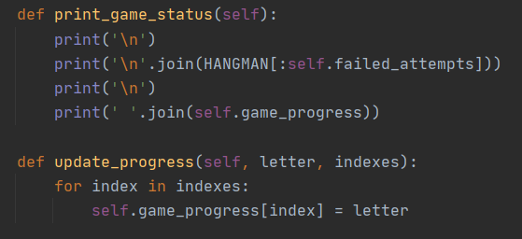

Followed PEP8 standard. Two line spaces between classes and one line space between methods. Used four spaces per identation level.

1. **Tests**

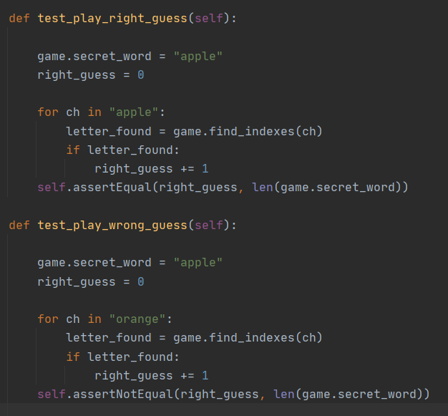

Defined tests that are fast and independent. Used only one assert per test. These tests are easily readable and easy to run.